PERSONAL INFORMATION | Nino Butsashvili
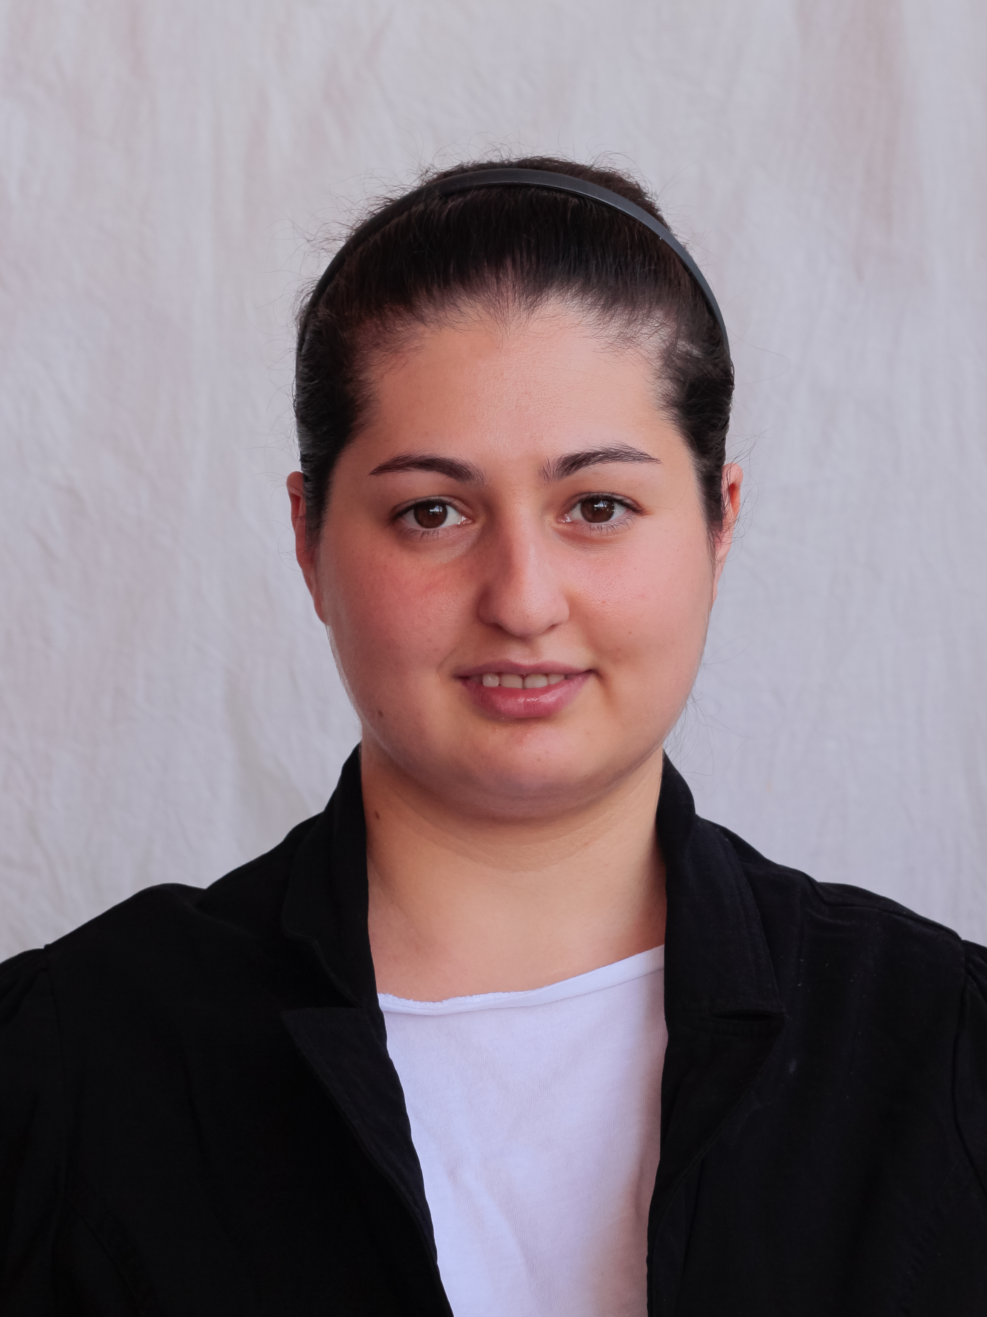

nino.butsashvili@iliauni.edu.ge

WORK EXPERIENCE

2024-present | Director’s assistant/Researcher  Dimitri Uznadze Institute of Psychology, Ilia State University. KaKutsa Cholokashvili Ave  3/5, Tbilisi, Georgia. www.iliauni.edu.ge www.iliauni.edu.ge  - Participating in research/project planing  - Conducting interviews  - Translating questionnaires  - Data processing.  - Technical editing.

2023-present | Invited Lecturer  Ilia State University. KaKutsa Cholokashvili Ave 3/5, Tbilisi, Georgia. www.iliauni.edu.ge www.iliauni.edu.ge  - Theaching at Bachelor level.

2015-2023 | Assistant/Translator/Researcher  Dimitri Uznadze Institute of Psychology, Ilia State University. KaKutsa Cholokashvili Ave 3/5, Tbilisi, Georgia. www.iliauni.edu.ge www.iliauni.edu.ge  - Conducting interviews  - Translating questionnaires  - Sorting, arranging data  - Technical editing.

2014 | Assistant/Translator/Researcher  4D Institute, Ilia State University. KaKutsa Cholokashvili Ave 3/5, Tbilisi, Georgia. www.iliauni.edu.ge www.iliauni.edu.ge  - Sorting, arranging data  - Technical editing.

EDUCATION

2019-2024  2015-2017  2010-2014 | PhD  Ilia State University  - Psychology  Master  Ilia State University  - Social Psychology  Bachelor in Social Science  Ilia State University  - Psychology

TRAINING, SHORT COURSES

- Active Learning in the Flipped Classroom. 27-29 November. Ilia State University.
- Training on Gender Statistics. 5-6 February, 2020. Geostat, UN Women.
- Statistics and Data Analysis, Short Course. 9-10 July, 2019. Ilia State University, Doctoral School
- Research Design and Research Methods in the Social Sciences, Workshop. 17-18 May, 2019. ARISC.
- Understanding and Navigating Experiences of Racial Discrimination for International Students. 10 April, 2019. APA

PERSONAL SKILLS

Mother tongue(s) | Georgian
Other language(s) | UNDERSTANDING |  | SPEAKING |  | WRITING
Other language(s) | Listening | Reading | Spoken interaction | Spoken production
English | 8.5 | 8.0 | 6.5 | 6.5 | 6
 | IELTS academic. C1 Independent user.

Digital competence | SELF-ASSESSMENT
Digital competence | Information processing | Communication | Content creation | Safety | Problem solving
 | Proficient user | Proficient user | Proficient user | Proficient user | Proficient user
 | - Programs: Microsoft office, LibreOffice, SPSS, Mpus (basic user).

ADDITIONAL INFORMATION

Publications  Editorial Work  Conferences  Honours, awards, Scholarship | - Javakhishvili, N., & Butsashvili, N. (2023). Contestation but not Euroscepticism: economic and security concerns and the fear of losing national traditions in Georgia. Southeast European and Black Sea Studies, 1-19. https://doi.org/10.1080/14683857.2023.2269780  - Javakhishvili, N., Butsashvili, N., Gogibedashvili, A., & Vardanashvili, I. (2023). Georgian students’ perceived vitality, competence and behavioral intention to german-speaking out-group. InPACT 2023 Conference Proceedings.  - Shekriladze, I., Javakhishvili, N., Butsashvili, N., & Lortkipanidze, M. (2022). Anxiety, Worry, Life Satisfaction and Coping during the Acute VS Prolonged Pandemic Stress: Evidence from a Repeated Cross-Sectional Study. International Journal of Public Health, 92. https://doi.org/10.3389/ijph.2022.1604650  - Javakhishvili, N., Butsashvili, N., Vardanashvili, I., & Tordua, K. (2021). Women in the Eyes of Football Fans: Warm, Competent, Admirable. Georgian Psychological Journal, 3, 101-114.  - Javakhishvili, N., Butsashvili, N., Vardanashvili, I., Tordua, K., & Gogibedashvili, A. (2021). Social-Structural Antecedents Come forward to Elicit Envy to Distant Out-Groups. Frontiers in Psychology, 12, 1677.  - Javakhishvili, N., & Butsashvili, N. (2018). Domestic violence in Georgia: state and community responses, 2006-2015. In M. Barkaia & A. Waterston (eds.), Gender in Georgia: Feminist Perspectives on Culture, Nation and History in the South Caucasus. New York, NY: Berghahn Books.  - Vardanashvili, I., Makashvili, A., Javakhishvili, N., & Butsashvili, N. (2017). Developing Georgian version of prejudice measure. GESJ: Education Sciences and Psychology, 45(3), 86-99, (in Georgian). gesj.internetacademy.org.ge/download.php?id=3004.pdf&t=1  - Butsashvili, N. (2016). Support of multiculturalism and ethnic belonging. Proceedings of Psychological Conference Dedicated to D. Uznadze's Jubilee, pp. 63-84 (in Georgian).  - Javakhishvili, N., Skhirtladze, N., Butsashvili, N., Lortkipanidze M., Makashvili, A., Vardanashvili, I., Shekriladze, I. (2016). Validation of Research Instruments. Proceedings of Psychological Conference Dedicated to D. Uznadze's Jubilee, pp. 63-84  - Javakhishvili, N., & Butsashvili, N. (eds). (2020). D. Uznadze Works and their Modern  - interpretation (in Georgian). Tbilisi: Ilia State University Press.  - Javakhishvili, N., & Butsashvili, N. (eds.). (2019). D. Uznadze Selected Works Commented by Contemporary Georgian Scholars (second edition). KEW Ed. Poland.  - Javakhishvili, N., & Butsashvili, N. (eds.). (2018). D. Uznadze Selected Works Commented by Contemporary Georgian Scholars. Tbilisi: Ilia State University Press.  - Javakhishvili, N., & kavtaradze, I., & Butsashvili, N. (eds.). (2016). Proceedings of Psychological Conference Dedicated to D. Uznadze's Jubilee (in Georgian).  - Butsashvili, N., Javakhishvili. N., Makashvili, A., & Kosic, A. (2024). Conspiracy Beliefs Shape Attitude to War in Ukraine. 28-29 June. Kent, UK.  - Butsashvili, N., & Javakhishvili. N. (2022). BIAS map model in the Georgian context. Current issues of psychology and educational sciences 2022. December 16, Tbilisi, Georgia.  - Lortkipanidze, M., & Javakhishvili, N., & Butsashvili, N. (2022). The mediating role of anxiety between intimate partner violence and depressive symptoms. WPA. 14-16 October, Tbilisi, Georgia  - Butsashvili, N. (2016). Support of multiculturalism and ethnic belonging. Psychological Conference Dedicated to D. Uznadze's Jubilee. December 2, 2016, Tbilisi, Georgia.  - Butsashvili, N. (2014). Dimensions of Identity, basic psychological styles and parenting. Students’ conference 2014. Ilia State University. Tbilisi. Georgia.  - Erasmus + Exchange student. Université Libre de Bruxelles, Brussels, Belgium, 2023.  - Erasmus + Exchange student. University of Granada, Granada, Spain, 2022.  - Erasmus + Exchange student. La Sapienza, Rome, Italy, 2021-2022.  - Master diploma with honours. (2017).  - Scholarship of Mayor of Tbilisi for excellent academic performance. (2015-2017).  - Presidential/State scholarship for excellent academic performance. (2011-2014).  - Golden medal for excellent studying at school. (2010).

Courses | - Principles of Social Psychology, Seminar (Bachelor)  - Experimental Psychology, Seminar (Bachelor)  - Psychology of emotion, Seminar (Bachelor)  - Introduction in Psychology, Seminar (Bachelor).

Project Participation | - Personal, social and Cultural Identity in the Changing Society. (2024-ongoing). Ministry of Education and Science of Georgia. Researcher.  - Mental Health. (2024-ongoing). Ministry of Education and Science of Georgia. Researcher.  - Preservation, Popularization and Development of Dimitri Uznadze's Legacy. (2024-ongoing). Ministry of Education and Science of Georgia. Researcher.  - Validation of Research Instruments. (2024-ongoing). Ministry of Education and Science of Georgia. Researcher.  - Attitudes toward Current World Issues. (2022- ongoing). EASP. Researcher.  - Response to Culture Change Among Georgian Immigrants and Sojourners. Shota Rustaveli National Science Foundation of Georgia. (2021-2023). Assistant.  - Evaluation of Women’s fund’s projects’ efficiency and its organizational capacity. (2020). Women’s Fund. Georgia. Researcher.

